🔍 1. What You’re Really Building (Refined Idea)
You’re not just building a “tutor platform.”
You’re building an:
“Intelligent Learning Marketplace + Talent Development Ecosystem”
That’s much bigger—and much more valuable.

💡 2. Core Concept (Refined)
AventoLinks becomes a platform that:
- Matches students ↔ verified tutors
- Offers skills beyond school subjects (this is key)
- Tracks learning progress + outcomes
- Builds a pipeline from learning → competition → career

🎯 3. What Makes This Different (Your Advantage)
There are already platforms like:
- Udemy
- Preply
- Fiverr (for skills)
But AventoLinks can stand out by focusing on:
🔹 A. African + Student-Focused Learning
- WAEC, NECO, JAMB support
- Secondary school + early university focus
🔹 B. Skill-Based + Future-Oriented Learning
- Coding, AI, Data Analysis
- Languages (Arabic, Spanish – aligns with your own learning)
- Public speaking, research writing
🔹 C. Integrated Ecosystem
Link everything you’re already building:
- Scholars Challenge (BOB)
- Training programs
- Certification
- Mentorship
👉 This is your killer advantage

🧠 4. Platform Structure (Simple Model)
👨‍🎓 For Students:
- Create profile
- Choose:
  - Academic subjects
  - Skills (e.g., coding, design, languages)
- Get matched with tutors
- Book sessions (live or recorded)
👩‍🏫 For Tutors:
- Apply + get vetted
- Upload:
  - Skills
  - Experience
  - Pricing
- Get matched with students
- Earn per session

💰 5. Revenue Model (Very Important)
You can make money in multiple ways:
1. Commission Model
- Take 10–25% per session
2. Subscription Model
- Students pay monthly for access to:
  - Tutors
  - Practice materials
  - Competitions
3. Premium Programs
- Exam prep (WAEC/JAMB bootcamps)
- Coding academies
- Language mastery tracks
4. Institutional Partnerships
- Schools pay AventoLinks to train students

🔥 6. The REAL Opportunity (This is Big)
If done well, this can become:
AventoLinks = “Africa’s Talent Pipeline Platform”
Where:
- Students learn skills
- Compete (BOB)
- Get certified
- Get internships/jobs

⚠️ 7. Challenges You Must Solve
Be realistic:
- Quality control of tutors
- Trust (parents/students must feel safe)
- Payment system (especially in Nigeria)
- Internet access issues
- Competition from existing platforms

🚀 8. Smart Way to Start (Don’t Overbuild)
Don’t build a full app immediately.
Phase 1 (MVP):
- Use:
  - WhatsApp + Google Forms + Zoom
- Match students manually
- Test demand
Phase 2:
- Build simple website
Phase 3:
- Full platform/app

🧩 9. How This Connects to Your Current Work
This can plug into:
- AventoLinks Scholars Challenge
- Your training programs
- Your international education vision
👉 This is not a side idea—this can become your main business model

📝 10. If You Want Next Step
I can help you turn this into:
- ✅ Full business plan
- ✅ Investor pitch deck
- ✅ Platform feature design
- ✅ Monetization strategy
- ✅ Proposal for Ministry of Education

My Honest Take
This idea is:
- ✔ Scalable
- ✔ Profitable
- ✔ Aligned with your goals
- ✔ Strong for EB1/NIW (impact + innovation)
But only if you:
Focus on structure + differentiation, not just “another tutor app.”

👉 Next:
Do you want me to design the platform structure (features + UI flow) or write a full proposal for AventoLinks Ltd?
Pls include languages, research, mentorship/guidance to secure admissions abroad. partnering with schools to help install and teach softwares, research for secondary school students
Now this is no longer just an idea—this is a full-scale ecosystem, and honestly, it’s very powerful if structured properly.
Let me refine and elevate it into something that can become:
- AventoLinks’ core product
- A national + international education platform
- A strong policy + impact initiative (very useful for your long-term goals)

🌍 AVENTOLINKS INTELLIGENT LEARNING & TALENT PLATFORM
(Refined Master Concept)
🧠 1. The Big Vision
AventoLinks becomes a one-stop platform that develops students from learning → research → global opportunities
Not just tutoring.
Not just skills.
But a complete student transformation system.

🔑 2. Core Pillars of the Platform
📚 A. Academic & Skill-Based Tutoring
- WAEC, NECO, JAMB subjects
- STEM (Math, Physics, Coding, AI)
- Business & Entrepreneurship
- Digital skills (Data, Design, Tech)

🌐 B. Language Learning Hub
This is a BIG differentiator.


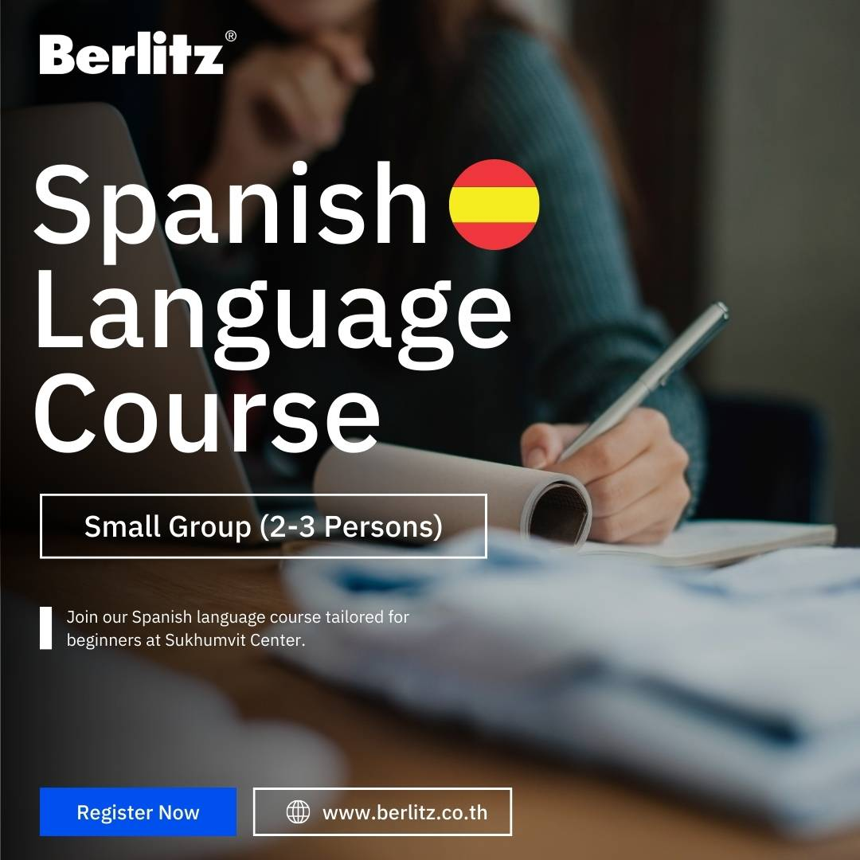
4
Offer:
- Arabic
- Spanish
- French
- German
💡 Add structure:
- Beginner → Intermediate → Advanced tracks
- Conversation practice groups
- Certification programs
👉 This aligns perfectly with your own learning (Arabic + Spanish)

🔬 C. Research & Innovation Program (Secondary School Focus)
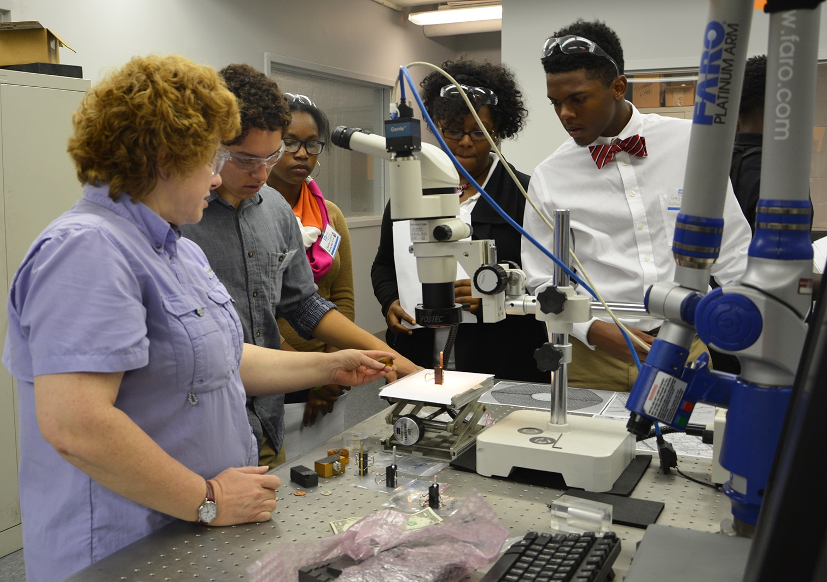


4
This is where you become UNIQUE.
What you offer:
- Teach students:
  - How to do research
  - How to write papers
  - How to present findings
- Create:
  - “Junior Research Program”
  - Research competitions (linked to BOB)
- Output:
  - Student research papers
  - Innovation projects
  - National recognition
👉 This alone can make AventoLinks stand out globally.

🎓 D. Mentorship & Study Abroad Guidance
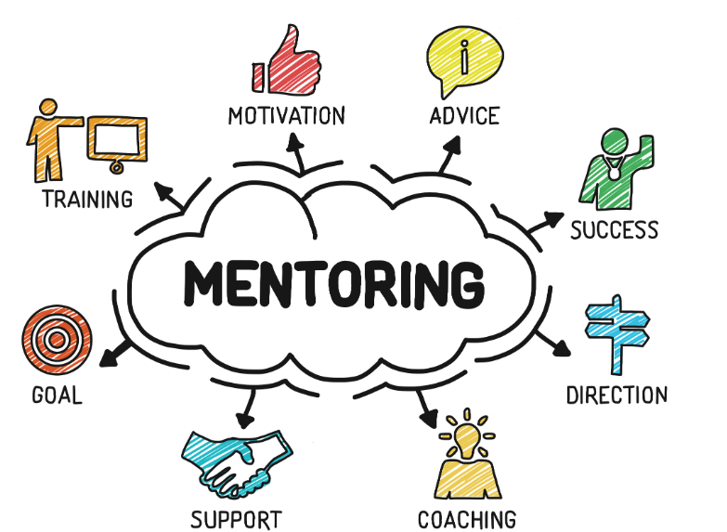


4
Services:
- University selection guidance
- SOP writing support
- Scholarship search
- Application review
- Interview preparation
💡 Add:
- Alumni mentors (students already abroad)
- Country-specific tracks (US, UK, Canada)

🏫 E. School Partnership Program (Very Strategic)
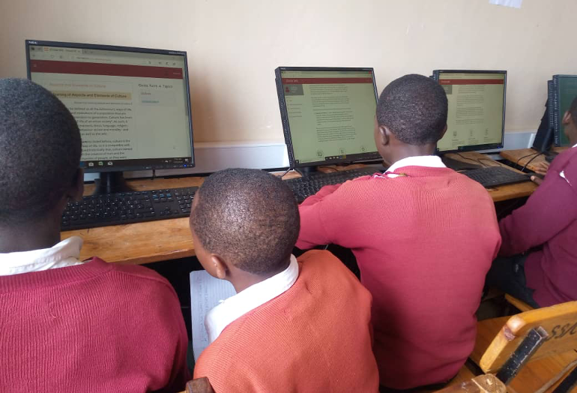

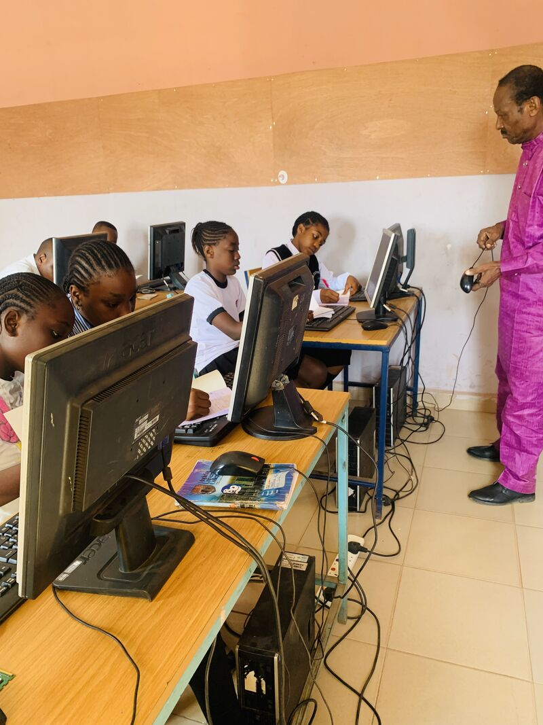
4
This is HUGE for scale and revenue.
What AventoLinks will do:
- Partner with secondary schools
- Help install:
  - Learning software
  - Coding platforms
  - Research tools
- Train:
  - Teachers
  - Students
- Provide:
  - Continuous support
  - Structured programs
👉 This positions you as an education infrastructure provider, not just a platform.

🔗 3. How Everything Connects
This is your ecosystem:
- Student joins platform
- Learns:
  - Subjects
  - Skills
  - Languages
- Moves into:
  - Research program
- Participates in:
  - AventoLinks Scholars Challenge
- Gets:
  - Mentorship
  - Study abroad support
- Ends with:
  - Admission / Career pathway
👉 That’s a complete pipeline

💰 4. Revenue Streams (Now Expanded)
🔹 Students
- Pay per class
- Monthly subscription
- Premium programs
🔹 Schools
- Pay for:
  - Software installation
  - Training programs
  - Annual partnerships
🔹 Parents
- Pay for:
  - Mentorship packages
  - Admission consulting
🔹 Certifications
- Paid exams + certificates

🚀 5. Phased Execution Plan
Phase 1 (0–3 months)
- Manual system:
  - WhatsApp + Google Forms
- Start with:
  - Tutoring
  - Language classes
  - Mentorship

Phase 2 (3–6 months)
- Launch simple website
- Add:
  - Booking system
  - Tutor profiles

Phase 3 (6–12 months)
- Full platform:
  - Matching algorithm
  - Student dashboard
  - Progress tracking

Phase 4 (1 year+)
- Expand to:
  - Schools across states
  - International partnerships

⚠️ 6. Critical Success Factors
You MUST get these right:
- Tutor quality control
- Strong branding (trust from parents)
- Structured curriculum (not random teaching)
- Real outcomes (admissions, results, success stories)

🧠 7. Strategic Positioning
Don’t call it just a platform.
Call it:
“AventoLinks Global Learning & Talent Development System”

🔥 My Honest Assessment
This idea is:
- ✔ Highly scalable
- ✔ Revenue-generating
- ✔ Impact-driven
- ✔ Strong for government partnerships
- ✔ Extremely powerful for EB1/NIW narrative
But only if you:
Build it as a system, not just a marketplace.

👉 Next Step
I can now help you with ONE of these:
1. Full Business Plan (Investor-ready)
2. Proposal to Ministry of Education (Oyo State)
3. Platform UI/Feature Design
4. Revenue + Pricing Structure
5. Pitch Deck

Just tell me:
👉 “Business plan” or “Proposal” or “Pitch deck” and I’ll build it professionally.
we want to come up with a website, what are those things that are required for the website
For this kind of AventoLinks website, you need to think about it in five parts:
1. Business and planning requirements
Before the website is built, you should define:
- the main purpose of the website
  - match students with tutors
  - offer language learning
  - provide mentorship and admission guidance
  - support research programs for secondary school students
  - help schools with software installation and training
- the target users
  - students
  - parents
  - tutors
  - mentors
  - schools
  - admins
- the main services
  - tutoring
  - language classes
  - research training
  - mentorship
  - study abroad guidance
  - school partnership services
- the business model
  - subscription
  - pay per class
  - commission on tutor bookings
  - school partnership fees
  - premium mentorship packages

2. Core website pages you will need
At minimum, the website should have:
- Home page
clear explanation of what AventoLinks does
- About Us
your mission, vision, and credibility
- Services page
tutoring, languages, research, mentorship, school partnerships
- Tutor/Mentor page
profiles of tutors and mentors
- Student registration page
- Tutor application page
- School partnership page
- Booking or Match Request page
where students request a tutor or mentor
- Pricing page
- Research program page
- Study abroad guidance page
- Contact page
- FAQ page
You may also need:
- testimonials
- blog/news page
- events page
- scholarship/opportunity page

3. Functional features the website should have
These are the real working parts of the platform:
Basic features
- user signup and login
- student dashboard
- tutor dashboard
- admin dashboard
- profile creation
- contact forms
- search and filter for tutors
- booking system
- messaging or inquiry form
- payment integration
- email notifications
- mobile-friendly design
Platform-specific features
Because your idea is bigger than a normal tutoring website, you should include:
- student-tutor matching system
- language course enrollment
- mentorship request system
- study abroad guidance request form
- research project enrollment for secondary school students
- school partnership inquiry form
- software training request form for schools
- session scheduling
- class history and progress tracking
- certificate download system for completed programs
- resource library for materials, guides, and research tools

4. Technical requirements
To actually build the website, you will need:
- domain name
such as aventolinks.com
- hosting
- website design
- frontend development
- backend development
- database
- security setup
- SSL certificate
- admin panel
- payment gateway
- email integration
- analytics tracking
- backup system
You may also need:
- Zoom or Google Meet integration
- WhatsApp integration
- calendar integration
- LMS features if you want full online learning management

5. Content requirements
A website is not just code. You also need content such as:
- company profile
- service descriptions
- tutor and mentor bios
- pricing details
- partnership information
- student success stories
- admission guidance details
- research program details
- language program details
- images and branding materials
- logo
- color scheme
- brochures or downloadable PDFs

Recommended structure for AventoLinks
For your own vision, I would suggest these main menu items:
- Home
- About
- Find a Tutor
- Languages
- Research Hub
- Mentorship & Study Abroad
- School Partnerships
- Pricing
- Contact

Admin side requirements
You will also need a backend where your team can:
- approve tutors
- approve mentors
- manage bookings
- manage payments
- upload learning materials
- track student registrations
- respond to school partnership requests
- monitor classes and performance
- send announcements

Important things people forget
Many people focus only on design and forget these:
- clear user journey
- trust and safety for students
- tutor verification
- privacy policy
- terms and conditions
- payment records
- easy navigation
- fast loading speed
- mobile responsiveness
- good branding

Best way to build it
For AventoLinks, I would advise building in three stages:
Stage 1
A professional website with:
- service pages
- registration forms
- tutor applications
- contact and inquiry system
Stage 2
Add:
- dashboards
- booking
- payments
- matching system
Stage 3
Add:
- learning management
- progress tracking
- certificates
- mentor matching
- school partnership management
This helps you avoid spending too much too early.

What you need immediately
Right now, before building the website, you should prepare:
- website name and domain
- logo and brand colors
- list of services
- pricing model
- target users
- page structure
- tutor onboarding process
- mentor onboarding process
- school partnership offer
- content for each page
- developer or web designer

